Dawn L. Watkins
Greenville, South Carolina
Chapter 1
Vocabulary
Use a dictionary to define the words.
- Medallion
- thready
- neutral
- colonnade
Reading and Thinking
As you read chapter one, pay attention to how Trave feels about his position in the kingdom of Gadalla.
Answer the following questions.
l. What can you learn about Trave from the third paragraph on page 1?
- What does Trave wish to do the most?
- Why do you think Trave wants to assume the king's responsibilities at such a young age?
- How does Trave react to Umbo^{l}s disobedience?
- Do you think you would like to have Trave for a friend? Why or why not?
- Do you think Trave was correct in supposing King Panii did not allow him to have a horse because of fear? Why or why not?
- How do the wheelwright and the soldier feel about one another? Of the two, which one would probably be an enemy of the prince?
- Why is Trave so interested in the strange horse?
- List three adjectives that describe Gris?
- List three adjectives to describe Panii?
- What does Panii mean when he says, "Gadalla is for Gadalla"?
Biblical Application
Read Proverbs 14:17 and Proverbs 16:32, and answer the following questions.
- What does this verse say about anger?
- How can we control our anger when something happens to upset us?
Turn to the map in the front of your copy of Medallion and complete IA (the next page in this packet).
Chapter 2
Vocabulary
Use a dictionary to look up the meaning for each word listed. Write the definition next to the word.
- Humiliation
- inaudible
- massive
- gratitude
- foreigner
Read and Think — Read chapter two and answer the questions with complete sentences.
- What does Gris do that is different from what Trave expects a king to do?
- What does the author mean by saying that Trave feels like he has fallen into a hot spring during a cold rain?
- Why do you think Panii has refused to let Trave's father's name be spoken?
Name
Kapnos and the Under Countries
Turn to the map in the front of your copy of Medallion and answer the following questions.
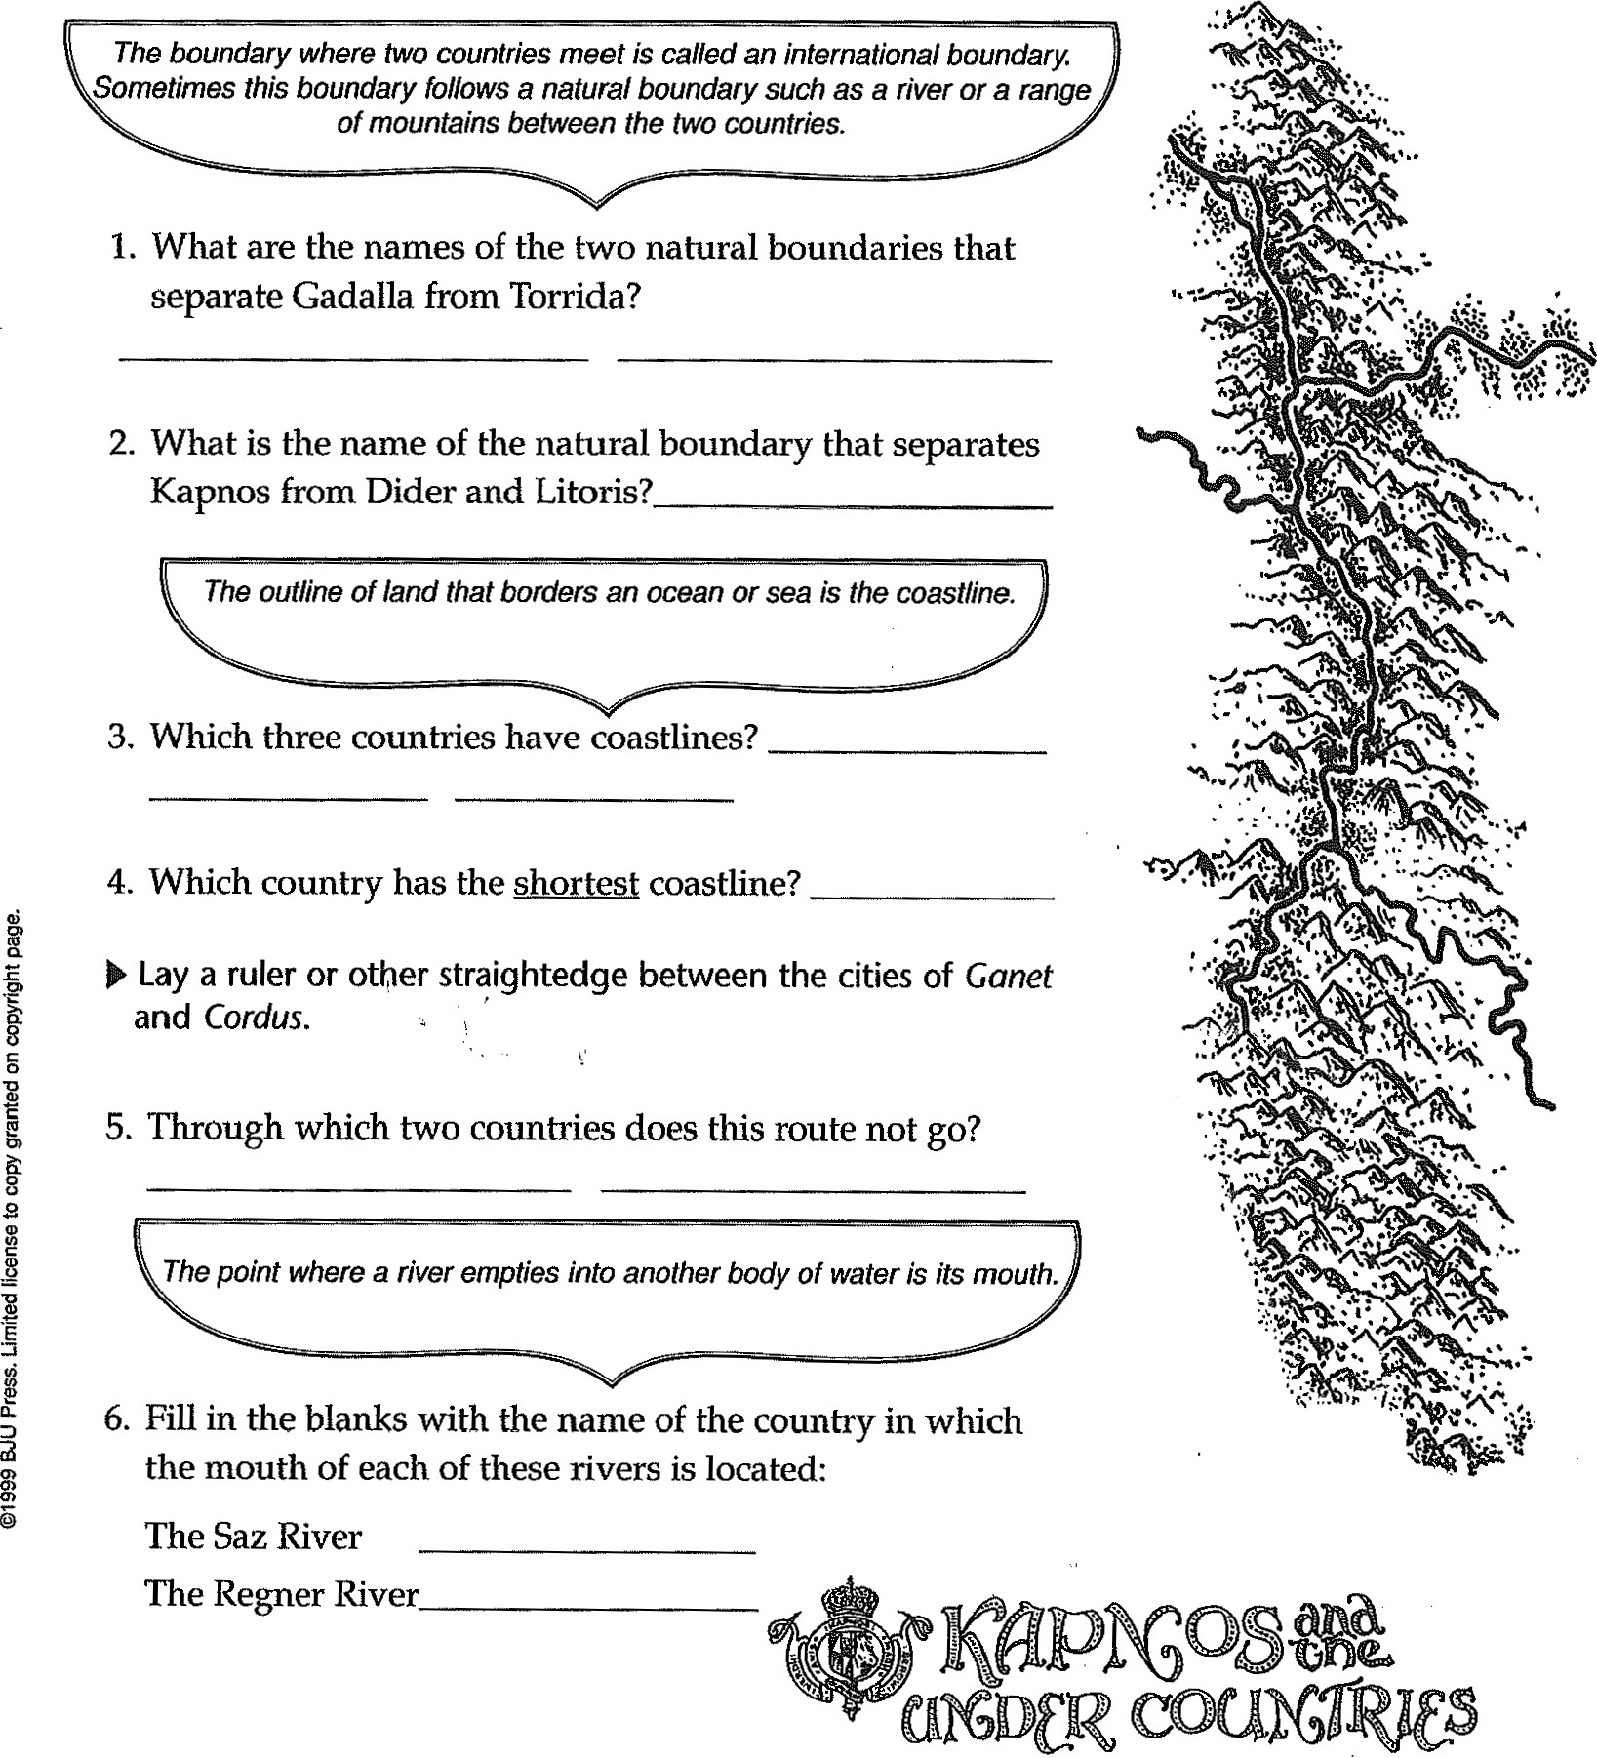The Regner River
- How does Trave^{r}s idea of being a great king differ from his father's?
- What is the purpose of the medallion that Dokos left with one of his men?
- Did Dokos mean for Trave to be king automatically? Why or why not?
- What was Trave^{r}s mother like?
- Why doesn't Trave answer when Gris asks his if he knows how to ride a horse?
Biblical Application
Read Jeremiah 9:23-24 and answer the question.
1. What do these verses say about greatness and goodness?
Chapter 3
Vocabulary — Write the definition of each word.
- quandary
- honing
3 pavilion
4. outrider
Reading and Thinking
Read chapter three, and answer the questions with complete sentences.
1. Why do you think Gris takes care of his horse before tending to his own needs?
2 What is the difference between Gris's and Trave^{t}s attitudes toward caring for Cene?
- Why doesn't Trave light the fire?
- How does Gris respond to Trave^{l}s inexperience?
- When the fire is out, why does Gris cover the place with a mound of dirt?
- Why does Cene respond so well to Gris's directions?
- Why do you think all the traders speak Gadallan when they come to Gadalla from other countries?
- Reread page 43. What action of Trave^{r}s shows how he feels about people of lower rank?
Biblical Application
Read Isaiah 43:1. How does God feel about each of us?
Chapter 4
Vocabulary — Write the definition for each word.
1. mortally 2. chiseled 3. resumed -
Read and Think,
Read chapter four and answer the questions with complete sentences.
- How does the author describe the stranger's eyes?
- What is the difference between Tanarad^{l}s opinion and Gris^{t}s opinion of Thag's actions?
3 Why is Trave sore in the morning?
- What is the purpose of the writing on the wall?
- Why does Trave refuse at first to obey the king's order to get into the boat?
- Why does Trave finally obey and get in the boat?
- How has Trave^{l}s attitude toward Gris changed at the end of this chapter?
Biblical Application
Read Proverbs 15:32, and answer the questions.
- Do you think Trave^{l}s response to correction in this chapter is right? Why or why not?
- What happens when we obey outwardly but not with our hearts?
Chapter 5
Vocabulary — Write the definition for each word.
- liege
- martingales -
3 eerie -
Read and Think
Read chapter five and answer the questions with complete sentences.
1 Why are the troops now speaking Kolonian rather than Gadallan?
- When the earthquake begins, why does Gris order the release of the spy?
- Do you think Gris was right to release the enemy? Why or why not?
- Why is the camp so quiet the night after the earthquake?
- How does Thag try to gain Trave^{l}s confidence?
- Why does Trave get angry when he sees Gris riding toward him?
Biblical Application
Read Proverbs 29:5 and Ephesians 4:29, and answer the questions.
- Who in the story could be described as a flatterer?
- How is the type of speech in Ephesians 4:29 different than flattery?
Complete the Earthquake and the Aftermath worksheet.
Chapter 6
Read and Think
Read chapter six and answer each question with a complete sentence.
- How does the author describe Rubrum, Sarda's capital?
- Why is Sard displeased when the council members express admiration for Thag?
- Why does Sard select Skreel Forest for the meeting place?
- What tlu•ee things does Sard want to accomplish?
Biblical Application
Read 1 Chronicles 29: 12 and answer the questions.
- According to this verse, from whose hand does power come?
- What is wrong with seeking power for ourselves?
Name
Earthquake and Aftermath?
An earthquake produces vibrations that move outward from a central occurrence. When an author constructs a plot (story line),
the action can move outward in several directions from an event.
Note how an event—the earthquake—causes the action in Medallion to move outward in certain directions.
Write your predictions of how the action will continue.
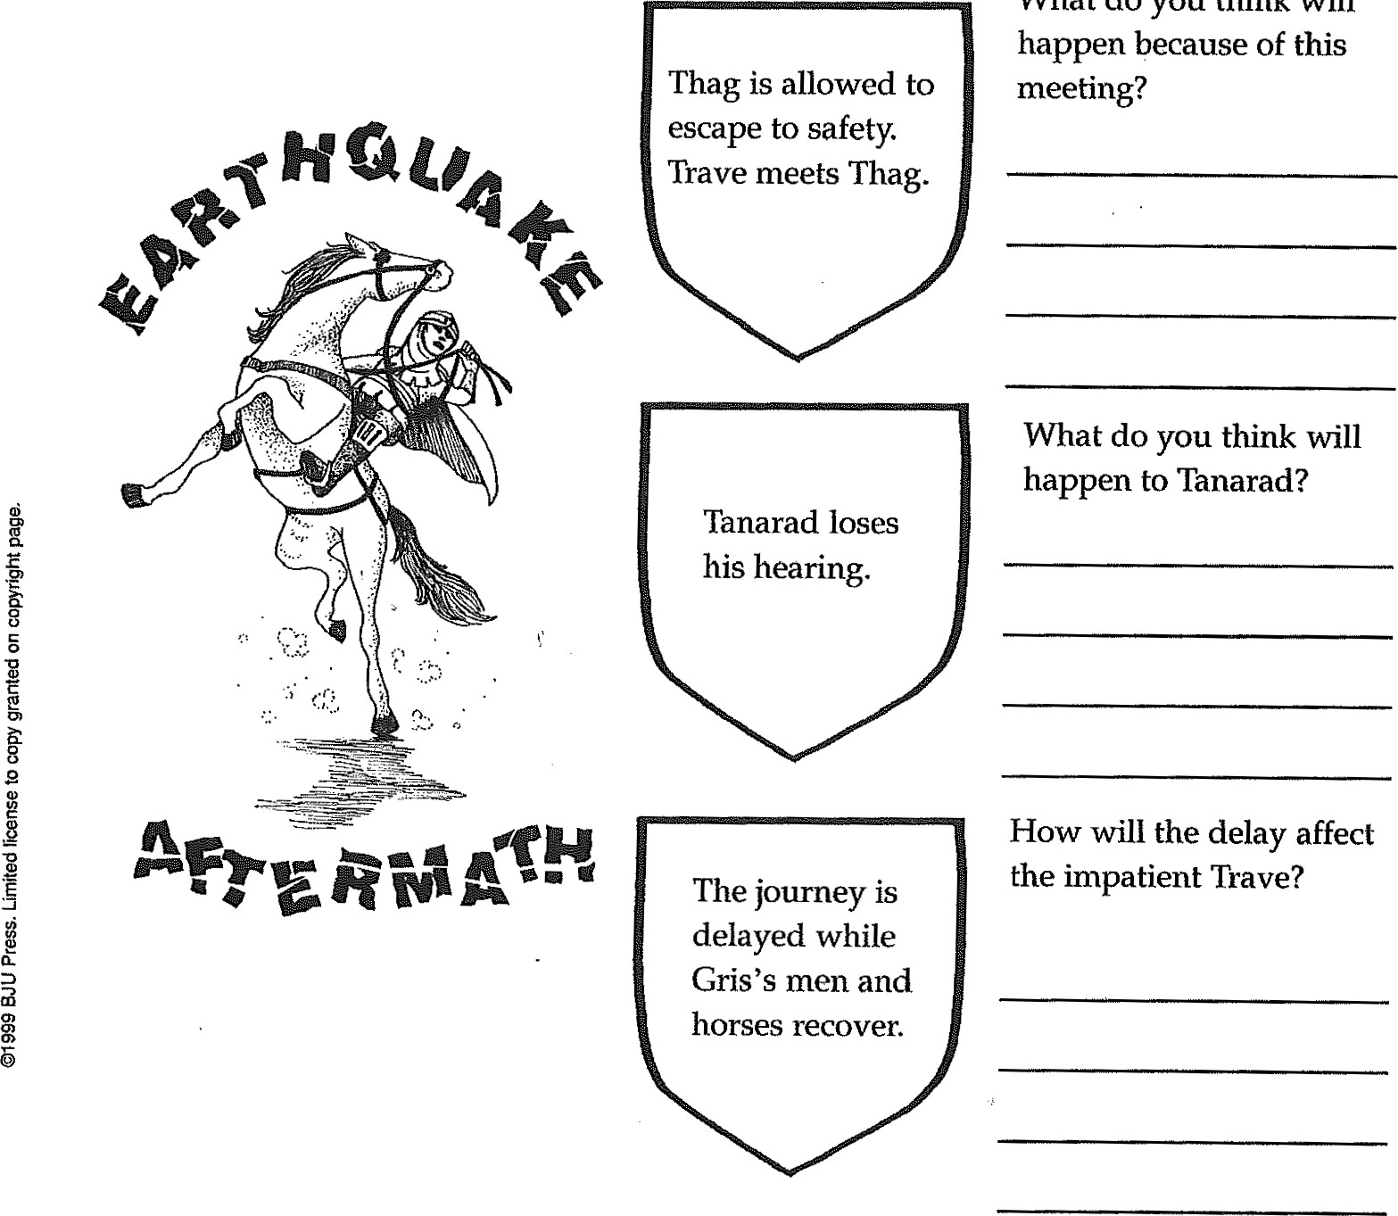meeting?
What
do
you
think
will
Chapter 7
Vocabulary — Define each of the words.
- roust -
- circumference -
- meander
- potential
Read and Think
Read chapter 7 and answer the questions with a complete sentence.
- Why doesn^{t}t Trave want to sleep where the soldiers sleep?
- Why does Gris send Trave to the center fires?
- What are the Ashenlanders like?
- How do Trave and Volar become friends?
- What happens that makes everyone laugh?
Biblical Application
Read Provers 18:24 and list ways we can show friendliness to others.
Chapter 8
Vocabulary — Write the definition for each word.
- federation -
- heritage -
- portico -
Read and Think
Read chapter 8 and answer the questions with a complete sentence.
- What is the mood at the beginning of this chapter?
- Why does Tanarad watch the musicians sadly?
- Why does Trave speak to the governor about Volar?
- Why is Gadalla^{l}s banner not displayed with the other flags at the council?
- Why is Gris still unsure about Trave's worthiness to be king?
- Why does Trave decide to go to Rock Tower?
Biblical Application
Read PIX)vers 16:32 and write what it means for a person to rule his spirit.
Chapter 9
Vocabulary — Write the definition of each word.
- musty 2. torrent -
Read and Think
Read chapter nine and answer each question with a complete sentence. 1. Why does Trave shoo Umbo into the trees?
- How does Sard win Trave to his side at the start of the conversation?
- What does Sard tell Trave about the medallion?
- If Trave asked your advice about going with Sard, what would you have told him?
Biblical Application
Read John 3:19 and I John 1:5, 2:11 and answer the questions.
l. Who is associated with light in the Bible?
2. What kinds of actions are associated with darkness in these verses?
Chapter 10
Read and Think
Read chapter ten and answer each question with a complete sentence.
- How would you feel if you were Trave at the beginning of this chapter?
- How does Nog respond when Trave tells him he is a prince?
- How does Nog identify Gadallans and Sardans?
- Do you think Nog is a wise or foolish character? Why?
Biblical Application
Read Proverbs 17: 17 and answer the question.
1. Name some ways you could be a loyal friend.
Chapter 11
Read and Think
Read chapter eleven and answer each question with a complete sentence.
- Why do you think Gris decided to go after Trave?
- Why does Gris choose Tanarad to be the leader until he returns?
- Once inside the forest, why doesn't Trave turn back?
4, Describe Skreel Forest.
- How does Trave find his way to the Sardan camp?
- What clues does Gris find that let him know he is on Trave^{t}s trail?
Biblical Application
Read Colossians 4:6 and answer the question.
1. What does it mean to speak with grace?
Chapter 12
Read and Think
Read chapter twelve and answer each question with a complete sentence.
- How does Sard flatter Trave upon their arrival at the camp?
- Why is Sard disturbed to find Trave missing?
- What punishment does Sard give Thag?
- Why does Sard call Trave a traitor?
Biblical Application
Read Jeremiah 17:9 and answer the questions.
- What does this verse say about the heart?
- Who can change a heat?
Chapter 13
Vocabulary — Define each word.
- furious
- exposed
- sluggish
Read and Think
Read chapter 13 and answer each question with a complete sentence.
- Why does Sard stay in the forest?
- Why do the Skreels attack the men?
- How do you know that Trave finally realizes he has been wrong?
- How is Sard's treatment of the wounded soldiers different than Gris^{l}s was after the earthquake?
- Why isn't a guard posted to watch Trave?
- To whom, does Trave call out in despair?
Biblical Application
Read 1 John 1 and answer the question?
1. In what way are Christians often like Trave?
Chapter 14
Vocabulary — Define each word.
1. crevice 2. turf -
3. ravme -
Read and Think
Read chapter 14 and answer each question with a complete sentence.
- Why do you think Gris releases the grelds before escaping with Trave?
- How does Trave get from the camp to Dider?
- Why does Gris turn east toward the Brass Mountain?
- What is unusual about Enna's cave?
- Why does Enna want Trave to think before he uses the medicine?
6.0f what does Trave need to be cured?
Biblical Application
Read Proverbs 2:11 and answer the question. What kind of person possesses wisdom?
Chapter 15
Read and Think
Read chapter fifteen and answer each question with complete sentences.
- How do you know that Trave^{l} s father was a good leader?
- Why do you think Trave is fearful when he hears of his father's humility?
- What is Gris^{t}s advice to Trave?
- How does Sard plan to get the Medallion?
- How has Umbo^{l} s training been useful for what Trave orders him to do now?
- How does the argument between Gris and Sard end?
- Why is Gadalla now in danger?
- How does the author show that Trave has given up his proud desire to rule?
- How does Gris surprise Trave?
Biblical Application
Read I John 4:4 and James 4:7 and answer the question.
How can these verses help you when you battle the temptation to do something wrong?
Chapter 16
Read and Think
Read chapter sixteen and answer each question with a complete sentence.
- How has Trave's attitude toward others changed since the beginning of the story?
- Why does Trave walk part of the way to the border of Torus Point?
- What gives Trave strength when he is so weary?
- What does Trave do that shows he has learned the value of honesty?
- Why do the men light a bonfire when Trave arrives?
- How has Thag's tone toward Trave changed?
- How do the soldiers show support for Trave?
Biblical Application
Read Acts 24: 16 and answer the question.
What type of conscience is important to Paul?
Chapter 17
Vocabulary — Define the following words.
1. frothing 2. Lathered -
Read and Think
Read chapter seventeen and answer each question with a complete sentence.
- Why does Tanarad tell Trave that he should not fight unless the battle is sore?
- What are the strengths of the Gadallan warriors?
- What main strength do the Sardans have?
- What tactic does Thag use to try to make the Diderans back off?
- How do Trave and Gris greet each other after the battle is won?
- What promise to the gatekeeper does Trave remember and keep?
- How has Trave shown himself worthy to wear the medallion and to be king of Gadalla?
Biblical Application
Read Matthew 20:26-28 and answer the questions.
- What did Jesus teach as the main quality of a leader?
- What are some ways you can be a servant at home and at school?
Use this page to make a new cover for this story. Be sure to include the author's name. Include a specific scene or details from the story.

