June, 2020

Dear Parents,

Enclosed you will find a list of math and reading requirements for children ***GOING INTO*** 1-8 grades.

In order to encourage success in the next grade we are requiring students to read and strengthen their skills by reviewing of math facts over the summer. (Please note 1st and 2nd grades are slightly different.)

The required readings are books we feel are excellent. They can be obtained at the public library but they are good books to buy and begin your own personal library. We encourage students to read more than the required amount. Thank you for your help with this. **The grade shown below is the one your child will enter in the fall.**

Also available for use through Scholastic is a summer reading website. If your child enjoys a challenge, using the computer or receiving awards, this website is available to you – http://www.scholatic.com/summer. Some of the current students are currently enrolled in this program. If you are new to the school you will need to register.

|  |  |  |
| --- | --- | --- |
| GRADE | MATH | READING |
| 1 | Practice addition and subtraction facts to 20. Know facts to 10.  Counting to 50 forward and backward  Counting by 5 and 10s to 100 | Students read 15 books to parents. Five books per month. A log is provided for your convenience and should be returned on the first day of school **(scroll down to see log attached).** |
| 2 | Addition and subtraction facts 1 – 10  Counting forward and backward 1 to 100  Skip counting by 2s, 5s and 10s | Students read 15 books to parents. Please keep the attached reading log to record title and number of pages to be returned on the first day of school. (**scroll down to see the log attached**). |
| 3 | Addition and subtraction facts 1 – 20  Practice skip counting by 2,3,4,5,6,7,8,9, & 10  Double digit addition and subtraction with regrouping  Examples: 12 21 219 321  +19 -12 +100 -133  3-digit addition and subtraction with regrouping | **Required Reading:**  Box Car Children Book #1 by Gertrude Chandler Warner |
| 4* | Please practice addition and subtraction facts 1-20 and multiplication facts to 12.  There will be fact tests the first week of school. Websites are available on my blog for fun math practice. | **Required Reading:**  The Cricket in Time Square by George Selden. We will complete several activities for this book the first few weeks of school.  Read as many books as you can for fun this summer and keep a list to bring the first day of school. |
| 5* | Practice and know all multiplication and division facts to and including 12 as a factor. Practice and know addition and subtraction facts. Be prepared for a test on each topic the first week back to school. It is essential that each fifth grade student have their math facts memorized for the first unit in math. | **Required Reading:**  The Medallion by Dawn L. Watkins  This book is published by BJU Press, and is also available on Amazon. We will begin the year with our unit of Christian Fantasy. Please complete the attached packet about The Medallion to be handed in on the first day of school. **(see 5th Grade Summer Reading Packet below)** |
| 6* | Multiplying up to a 3 digit number times a 3 digit number, dividing up to a 2 digit number into a 3 digit number with or without remainders, and multiplication and division facts 0 – 12 reducing fractions.  Adding, subtracting, multiplying & dividing decimals and fractions. | **Required Reading:**  Maniac Magee by Jerry Spinelli  Please complete the activity (**see BCS Middle School Summer Reading below)** |
| 7* | Multiplying up to a 3 digit number times a 3 digit number, dividing up to a 3 digit number into a 3 digit number with or without remainders, and multiplication and division facts 0 – 12. Add and subtract integers. Adding, subtracting, multiplying & dividing decimals and fractions. Solving one step equations with variables. Simplifying algebraic basic expressions. | **Required Reading:**  The Shakespeare Stealer by Gary Blackwood  Please complete the activity **(see** **7th Grade Summer Reading Shakespeare Stealer Worksheets below)** |
| 8* | Students coming into 8th grade must be able to add, subtract, multiply, and divide positive and negative numbers. Solve simple equations. Adding, subtracting, multiplying & dividing decimals and fractions. Simplify expressions. | **Required Reading:**  Among the Hidden by Margaret Peterson Maddix  Please complete the activity **(see** **BCS Middle School Summer Reading Sheet below)** |

NAME: _________________________________

**First Grade - Books I Read**

**Over the Summer**

FIRST GRADE

|  |  |  |
| --- | --- | --- |
| **TITLE** | **AUTHOR** | **PAGES** |
| 1. |  |  |
| 2. |  |  |
| 3. |  |  |
| 4. |  |  |
| 5. |  |  |
| 6. |  |  |
| 7. |  |  |
| 8. |  |  |
| 9. |  |  |
| 10. |  |  |
| 11. |  |  |
| 12. |  |  |
| 13. |  |  |
| 14. |  |  |
| 15. |  |  |

Name:



Summer

Reading Log

My goal for the summer is 15 books.

Please return the completed log to the teacher on the second day of school.

**I read:** Title of the book Number of pages

1

2

3

4

5

6

7

8

9

10

11

12

13

14

15

You may e-mail your list or turn in this form on the second day of school at jshaw@bethanychristian.org

Your Second Grade Teacher – Mrs. Shaw

5th Grade Reading

Chapter 1

Vocabulary

Use a dictionary to define the words.

1. Medallion
2. thready
3. neutral
4. colonnade

Reading and Thinking

As you read chapter one, pay attention to how Trave feels about his position in the kingdom of Gadalla.

Answer the following questions.

l. What can you learn about Trave from the third paragraph on page 1?

1. What does Trave wish to do the most?
2. Why do you think Trave wants to assume the king's responsibilities at such a young age?
3. How does Trave react to Umbols disobedience?
4. Do you think you would like to have Trave for a friend? Why or why not?
5. Do you think Trave was correct in supposing King Panii did not allow him to have a horse because of fear? Why or why not?
6. How do the wheelwright and the soldier feel about one another? Of the two, which one would probably be an enemy of the prince?
7. Why is Trave so interested in the strange horse?
8. List three adjectives that describe Gris?
9. List three adjectives to describe Panii?
10. What does Panii mean when he says, "Gadalla is for Gadalla"?

Biblical Application

Read Proverbs 14:17 and Proverbs 16:32, and answer the following questions.

1. What does this verse say about anger?
2. How can we control our anger when something happens to upset us?

Turn to the map in the front of your copy of Medallion and complete IA (the next page in this packet).

Chapter 2

Vocabulary

Use a dictionary to look up the meaning for each word listed. Write the definition next to the word.

1. Humiliation
2. inaudible
3. massive
4. gratitude
5. foreigner

Read and Think — Read chapter two and answer the questions with complete sentences.

1. What does Gris do that is different from what Trave expects a king to do?
2. What does the author mean by saying that Trave feels like he has fallen into a hot spring during a cold rain?
3. Why do you think Panii has refused to let Trave's father's name be spoken?

Name

Kapnos and the Under Countries

* Turn to the map in the front of your copy of Medallion and answer the following questions. 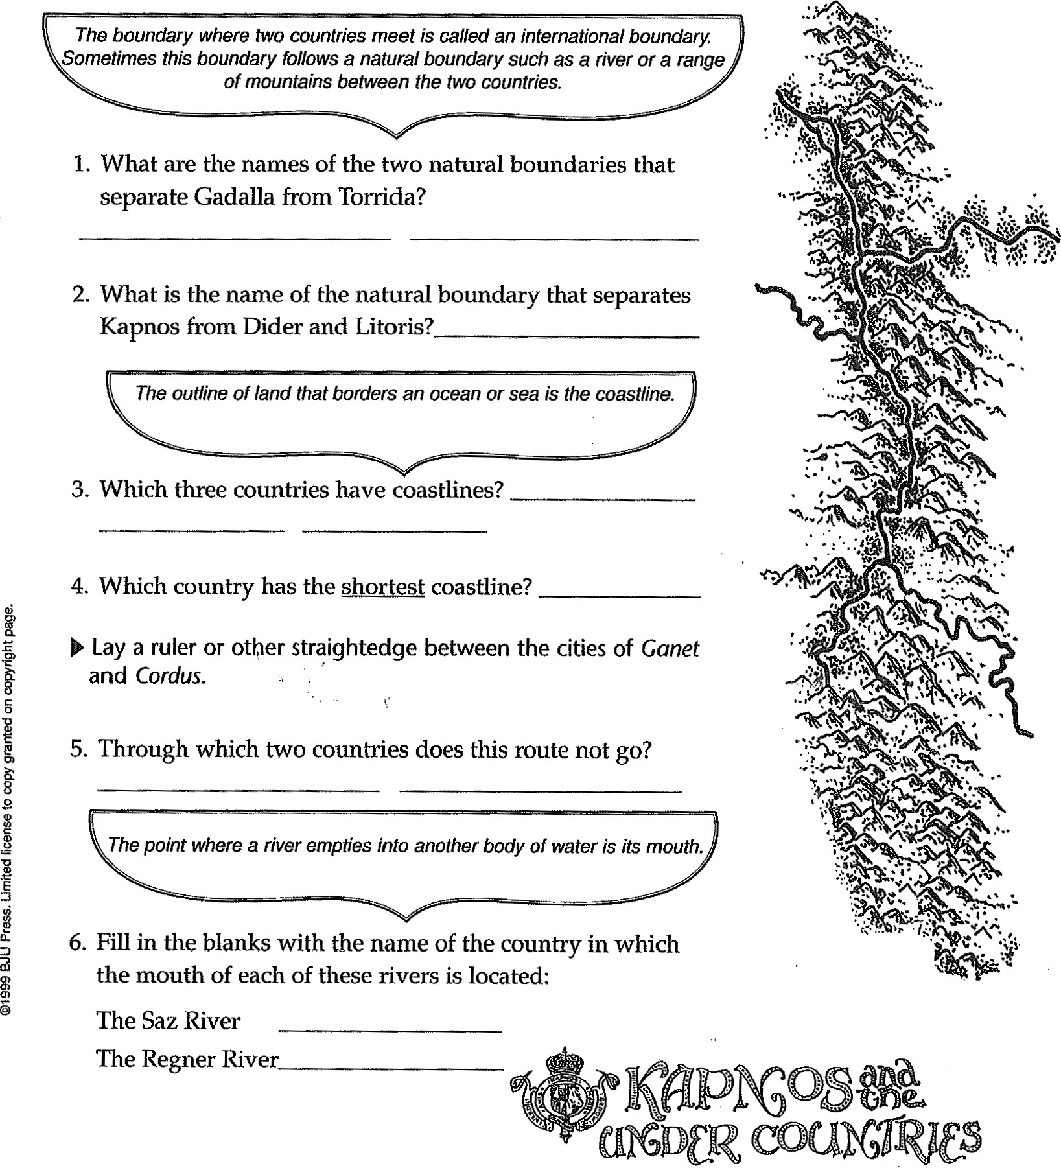

The Regner River

1. How does Travers idea of being a great king differ from his father's?
2. What is the purpose of the medallion that Dokos left with one of his men?
3. Did Dokos mean for Trave to be king automatically? Why or why not?
4. What was Travers mother like?
5. Why doesn't Trave answer when Gris asks his if he knows how to ride a horse?

Biblical Application

Read Jeremiah 9:23-24 and answer the question.

1. What do these verses say about greatness and goodness?

Chapter 3

Vocabulary — Write the definition of each word.

1. quandary
2. honing

3 pavilion

4. outrider

Reading and Thinking

Read chapter three, and answer the questions with complete sentences.

1. Why do you think Gris takes care of his horse before tending to his own needs?

2 What is the difference between Gris's and Travets attitudes toward caring for Cene?

1. Why doesn't Trave light the fire?
2. How does Gris respond to Travels inexperience?
3. When the fire is out, why does Gris cover the place with a mound of dirt?
4. Why does Cene respond so well to Gris's directions?
5. Why do you think all the traders speak Gadallan when they come to Gadalla from other countries?
6. Reread page 43. What action of Travers shows how he feels about people of lower rank?

Biblical Application

Read Isaiah 43:1. How does God feel about each of us?

Chapter 4

Vocabulary — Write the definition for each word.

1. mortally 2. chiseled 3. resumed -

Read and Think,

Read chapter four and answer the questions with complete sentences.

1. How does the author describe the stranger's eyes?
2. What is the difference between Tanaradls opinion and Grists opinion of Thag's actions?

 3 Why is Trave sore in the morning?

1. What is the purpose of the writing on the wall?
2. Why does Trave refuse at first to obey the king's order to get into the boat?
3. Why does Trave finally obey and get in the boat?
4. How has Travels attitude toward Gris changed at the end of this chapter?

Biblical Application

Read Proverbs 15:32, and answer the questions.

1. Do you think Travels response to correction in this chapter is right? Why or why not?
2. What happens when we obey outwardly but not with our hearts?

Chapter 5

Vocabulary — Write the definition for each word.

1. liege 
2. martingales -

3 eerie -

Read and Think

Read chapter five and answer the questions with complete sentences.

1 Why are the troops now speaking Kolonian rather than Gadallan?

1. When the earthquake begins, why does Gris order the release of the spy?
2. Do you think Gris was right to release the enemy? Why or why not?
3. Why is the camp so quiet the night after the earthquake?
4. How does Thag try to gain Travels confidence?
5. Why does Trave get angry when he sees Gris riding toward him?

Biblical Application

Read Proverbs 29:5 and Ephesians 4:29, and answer the questions.

1. Who in the story could be described as a flatterer?
2. How is the type of speech in Ephesians 4:29 different than flattery?

Complete the Earthquake and the Aftermath worksheet.

Chapter 6

Read and Think

Read chapter six and answer each question with a complete sentence.

1. How does the author describe Rubrum, Sarda's capital?
2. Why is Sard displeased when the council members express admiration for Thag?
3. Why does Sard select Skreel Forest for the meeting place?
4. What tlu•ee things does Sard want to accomplish?

Biblical Application

Read 1 Chronicles 29: 12 and answer the questions.

1. According to this verse, from whose hand does power come?
2. What is wrong with seeking power for ourselves?

Name

Earthquake and Aftermath?

An earthquake produces vibrations that move outward from a central occurrence. When an author constructs a plot (story line),

the action can move outward in several directions from an event.

 Note how an event—the earthquake—causes the action in Medallion to move outward in certain directions.

 Write your predictions of how the action will continue.

meeting?

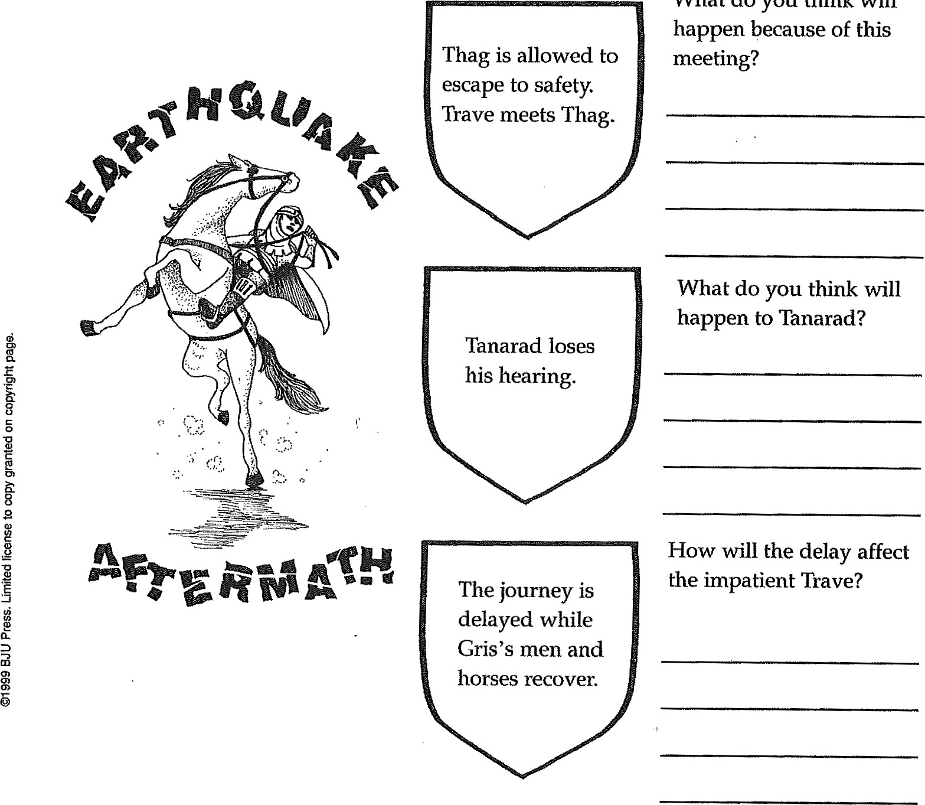

What

do

you

think

will

Chapter 7

Vocabulary — Define each of the words.

1. roust -
2. circumference -
3. meander
4. potential

Read and Think

Read chapter 7 and answer the questions with a complete sentence.

1. Why doesntt Trave want to sleep where the soldiers sleep?
2. Why does Gris send Trave to the center fires?
3. What are the Ashenlanders like?
4. How do Trave and Volar become friends?
5. What happens that makes everyone laugh?

Biblical Application

Read Provers 18:24 and list ways we can show friendliness to others.

Chapter 8

Vocabulary — Write the definition for each word.

1. federation -
2. heritage -
3. portico -

Read and Think

Read chapter 8 and answer the questions with a complete sentence.

1. What is the mood at the beginning of this chapter?
2. Why does Tanarad watch the musicians sadly?
3. Why does Trave speak to the governor about Volar?
4. Why is Gadallals banner not displayed with the other flags at the council?
5. Why is Gris still unsure about Trave's worthiness to be king?
6. Why does Trave decide to go to Rock Tower?

Biblical Application

Read PIX)vers 16:32 and write what it means for a person to rule his spirit.

Chapter 9

Vocabulary — Write the definition of each word.

1. musty 2. torrent -

Read and Think

Read chapter nine and answer each question with a complete sentence. 1. Why does Trave shoo Umbo into the trees?

1. How does Sard win Trave to his side at the start of the conversation?
2. What does Sard tell Trave about the medallion?
3. If Trave asked your advice about going with Sard, what would you have told him?

Biblical Application

Read John 3:19 and I John 1:5, 2:11 and answer the questions.

l. Who is associated with light in the Bible?

2. What kinds of actions are associated with darkness in these verses?

Chapter 10

Read and Think

Read chapter ten and answer each question with a complete sentence.

1. How would you feel if you were Trave at the beginning of this chapter?
2. How does Nog respond when Trave tells him he is a prince?
3. How does Nog identify Gadallans and Sardans?
4. Do you think Nog is a wise or foolish character? Why?

Biblical Application

Read Proverbs 17: 17 and answer the question.

1. Name some ways you could be a loyal friend.

Chapter 11

Read and Think

Read chapter eleven and answer each question with a complete sentence.

1. Why do you think Gris decided to go after Trave?
2. Why does Gris choose Tanarad to be the leader until he returns?
3. Once inside the forest, why doesn't Trave turn back?

4, Describe Skreel Forest.

1. How does Trave find his way to the Sardan camp?
2. What clues does Gris find that let him know he is on Travets trail?

Biblical Application

Read Colossians 4:6 and answer the question.

1. What does it mean to speak with grace?

Chapter 12

Read and Think

Read chapter twelve and answer each question with a complete sentence.

1. How does Sard flatter Trave upon their arrival at the camp?
2. Why is Sard disturbed to find Trave missing?
3. What punishment does Sard give Thag?
4. Why does Sard call Trave a traitor?

Biblical Application

Read Jeremiah 17:9 and answer the questions.

1. What does this verse say about the heart?
2. Who can change a heat?

Chapter 13

Vocabulary — Define each word.

1. furious
2. exposed
3. sluggish

Read and Think

Read chapter 13 and answer each question with a complete sentence.

1. Why does Sard stay in the forest?
2. Why do the Skreels attack the men?
3. How do you know that Trave finally realizes he has been wrong?
4. How is Sard's treatment of the wounded soldiers different than Grisls was after the earthquake?
5. Why isn't a guard posted to watch Trave?
6. To whom, does Trave call out in despair?

Biblical Application

Read 1 John 1 and answer the question?

1. In what way are Christians often like Trave?

Chapter 14

Vocabulary — Define each word.

1. crevice 2. turf -

3. ravme -

Read and Think

Read chapter 14 and answer each question with a complete sentence.

1. Why do you think Gris releases the grelds before escaping with Trave?
2. How does Trave get from the camp to Dider?
3. Why does Gris turn east toward the Brass Mountain?
4. What is unusual about Enna's cave?
5. Why does Enna want Trave to think before he uses the medicine?

6.0f what does Trave need to be cured?

Biblical Application

Read Proverbs 2:11 and answer the question. What kind of person possesses wisdom?

Chapter 15

Read and Think

Read chapter fifteen and answer each question with complete sentences.

1. How do you know that Travel s father was a good leader?
2. Why do you think Trave is fearful when he hears of his father's humility?
3. What is Grists advice to Trave?
4. How does Sard plan to get the Medallion?
5. How has Umbol s training been useful for what Trave orders him to do now?
6. How does the argument between Gris and Sard end?
7. Why is Gadalla now in danger?
8. How does the author show that Trave has given up his proud desire to rule?
9. How does Gris surprise Trave?

Biblical Application

Read I John 4:4 and James 4:7 and answer the question.

How can these verses help you when you battle the temptation to do something wrong?

Chapter 16

Read and Think

Read chapter sixteen and answer each question with a complete sentence.

1. How has Trave's attitude toward others changed since the beginning of the story?
2. Why does Trave walk part of the way to the border of Torus Point?
3. What gives Trave strength when he is so weary?
4. What does Trave do that shows he has learned the value of honesty?
5. Why do the men light a bonfire when Trave arrives?
6. How has Thag's tone toward Trave changed?
7. How do the soldiers show support for Trave?

Biblical Application

Read Acts 24: 16 and answer the question.

What type of conscience is important to Paul?

Chapter 17

Vocabulary — Define the following words.

1. frothing 2. Lathered -

Read and Think

Read chapter seventeen and answer each question with a complete sentence.

1. Why does Tanarad tell Trave that he should not fight unless the battle is sore?
2. What are the strengths of the Gadallan warriors?
3. What main strength do the Sardans have?
4. What tactic does Thag use to try to make the Diderans back off?
5. How do Trave and Gris greet each other after the battle is won?
6. What promise to the gatekeeper does Trave remember and keep?
7. How has Trave shown himself worthy to wear the medallion and to be king of Gadalla?

Biblical Application

Read Matthew 20:26-28 and answer the questions.

1. What did Jesus teach as the main quality of a leader?
2. What are some ways you can be a servant at home and at school?

**Use this page to make a new cover for this story. Be sure to include the author's name. Include a specific scene or details from the story.**

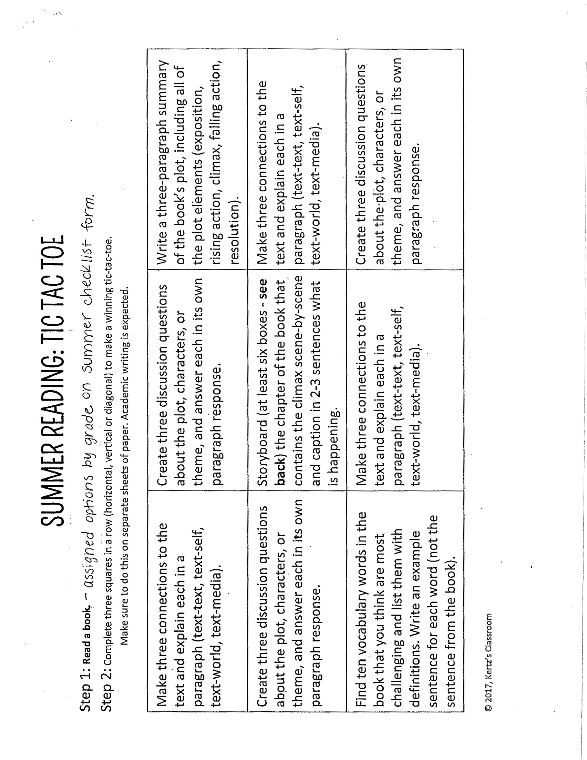

**MIDDLE SCHOOL SUMMER READING ACTIVITY SHEET**

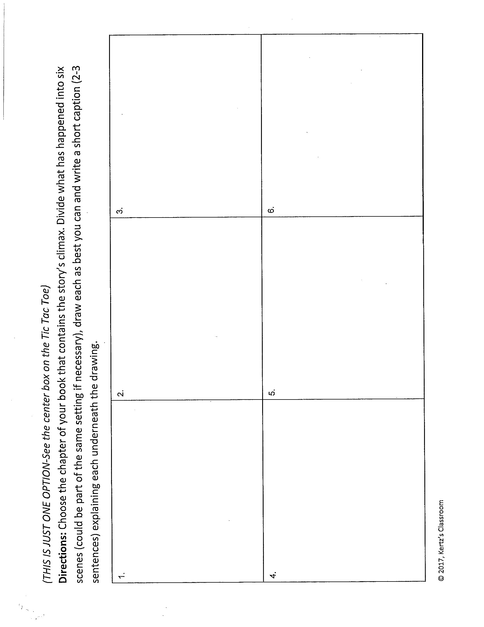

**7TH GRADE SUMMER READING SHAKESPEARE STEALER**

**Read book then complete 2 worksheets - Character Analysis: Before & After and this page! Summer Reading-incoming 7th**

Student Name______________________________________

**Character 1:** _________________________________________________________________________

Trait that described him or her early on in the book (w/example): __________________________________________________________________________________________________________________________________________________________________________________________________________

1. Event that affects that behavior: __________________________________________________________________

____________________________________________________________________________

1. Event that affects that behavior: __________________________________________________________________________

____________________________________________________________________________

1. Event that affects that behavior: __________________________________________________________________________

____________________________________________________________________________

Trait that describes him or her at the end of the book (w/example): _______________________________­­­­­­­­­­­­­­­­­­­­­­­­­­­____________________________________________________

______________________________________________________________________________________________________________________________________________________________________

**Character 2:** _________________________________________________________________________

Trait that described him or her early on in the book (w/example): __________________________________________________________________________________

___________________________________________________________________________________

___________________________________________________________________________________

1. Event that affects that behavior: _________________________________________________________________________

________________________________________________________________________________________________________________________________________________________

1. Event that affects that behavior: ________________________________________________________

____________________________________________________________________________

1. Event that affects that behavior: _________________________________________________________________________

____________________________________________________________________________

Trait that describes him or her at the end of the book (w/example)

_________________________________________________________________________________

__________________________________________________________________________________